Notice of Interim Meeting & Agenda
Tisbury Parish Council
The Reading Room, High Street, TISBURY, SP3 6LD
01747 260088 / 07388 376240
tisburypc@gmail.com / www.tisbury-wiltshire-pc.gov.uk
All Councillors are hereby summoned to attend the Parish Council Full Meeting to be held at the Reading Room on Tuesday 17th December 2019 at 7pm.
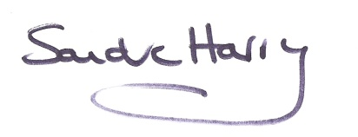
Sandra Harry - Parish Clerk
11th December 2019
The Chairman will confirm if any part of the meeting may not be filmed, photographed, or audio recorded.
If any member of the public has an objection to being filmed, photographed or audio recorded, please would they make themselves known to the Chairman or the Parish Clerk before the start of the meeting.
Questions or Statements
At 7pm there will be a short period of time set aside for questions and statements from members of the public only on the planning application below; each person speaking for no longer than 3 minutes.

INTERIM MEETING AGENDA
19.12.29 | Those present & resolution to accept apologies and reasons received for absence.
19.12.30 | - Declarations of Interest - any P.Cnllr wishing to declare interests should do so at this point:  - declarations of disclosable pecuniary and non-pecuniary interests already declared in the Register of Interests.  - declarations of disclosable pecuniary and non-pecuniary interests not previously declared in the Register of Interests.  - Dispensations: if required.
19.12.31 | Planning Application – resolution required  19/10662/LBC - Flat 1, Zion Hill, Cuffs Lane Tisbury SP3 6LG  To replace the existing wooden main entrance door and side screen to the block of  flats as old and in poor condition. The new door and side screen will be the same  design as existing but manufactured in aluminium for a more secure and effective  operation.
19.12.32 | Date of next meetings: all at 7pm in the Reading Room unless otherwise stated:  - Full Meeting – 13th January 2020  - Full Meeting – 4th February 2020  Note: the Reading Room is open for 30 minutes prior to the start of any public meeting for questions from any resident relating to planning applications.

